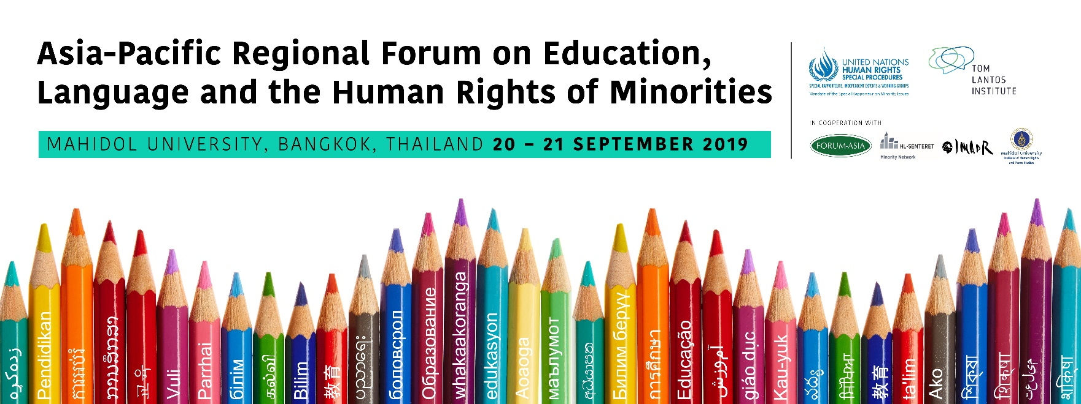

Program of Work

FRIDAY 20TH SEPTEMBER
08:30-09:05
Room Location: Tawee Wattana I & II Salaya Pavilion Hotel and Training Center, Mahidol University
The session is chaired by Anna-Mária Bíró
Welcoming remarks
- Eakpant Pindavanija, Director of Institute of Human Rights and Peace Studies (IHRP), Mahidol University (5 minutes)
- Jeffrey Senior, Counsellor (Political/Economic) and Permanent Observer to ESCAP, Embassy of Canada (5 minutes)
- Nopraenue Sajjarax Dhirathiti, Acting Vice President for International Relations and Corporate Communication,Mahidol Universitz (5 minutes)
Opening remarks
- Fernand de Varennes, United Nations Special Rapporteur on Minority Issues (7 minutes)
- Chirizzi Katia, Deputy Regional Representative, OHCHR Regional Office for South-East Asia (7 minutes)
- Maki Hayashikawa, Chief of Section for Inclusive Quality Education, UNESCO Bangkok (7 minutes)

09:05-09:30 Introductions, Rules and Guide to Proceedings
Room Location: Tawee Wattana I & II Salaya Pavilion Hotel and Training Center, Mahidol University
Anna-Mária Bíró, Director of the Tom Lantos Institute, will set-out the process.
Sriprapha Petcharamesree will explain the rules of proceedings for the regional forum.
Sriprapha Petcharamesree will moderate the introduction of participants who, if they wish, very briefly introduce themselves to the regional forum.

09:30-10:00 Presentation on OSCE’s Education Programme in Central Asia by Mr. Michael Angermann
Room Location: Tawee Wattana I & II Salaya Pavilion Hotel and Training Center, Mahidol University
The OSCE High Commissioner on National Minorities has been promoting mother tongue based multilingual education for national minorities in Central Asia for more than 15 years. Project Officer of the HCNM Central Asia Education Programme, Michael Angermann, will focus in his presentation on the two country cases of Kazakhstan and Kyrgyzstan as well as discuss the impact of the HCNM involvement. A number of conclusions will be formulated based on the countries’ best practices and existing challenges.

10:00-10:10 Coffee Break

10:15-12:30 Plenary: Experts present the 3 themes to be further discussed in working groups
Room Location: Tawee Wattana I & II Salaya Pavilion Hotel and Training Center, Mahidol University
The panel discussion will be introduced by Fernand de Varennes and moderated by Anna-Mária Bíró
In this introductory panel, each of the 3 themes will be presented by experts in the issue area, outlining the issues to be discussed in the subsequent working groups in order to develop and draft recommendations. It is envisaged that each working group will draft minimum 5 recommendations on the topic.
There will be an opportunity during the session for participants to raise questions to the experts under each theme.

Introduction by Fernand de Varennes (15 minutes)
Dr de Varennes will introduce the background and process of the regional forums, why the topic of education in and teaching of minority languages is the first topic to be covered by the regional forum format and also set-out the normative context, noting the strengths and weaknesses of the international normative framework
Expert introduces 1st Theme - Human Rights and minority language education (15 minutes presentation followed by 25 minutes Q & A)
Is there a right to education in and teaching of a minority language, and if so how should the right be implemented? This is one of the central issues for many minority communities around the world. While some European instruments address the issue, these tend to still be fairly general, open to interpretation, or even misunderstood, particularly in relation to the relationship between human rights obligations and the use of (minority) languages in education.
This theme and working group will discuss the interaction between existing human rights standards and education in minority languages, considering the circumstances for such rights claims. It will also look at what minorities actually want when it comes to the teaching of and in their languages, as well as what States can provide when considering the principles of proportionality and reasonableness.
Question and Answer session

Expert introduces 2nd Theme – Public policy objectives and practices for education in minority languages (15 minutes presentation followed by 25 minutes Q & A)
The implementation of human rights resulting in education in and teaching of minority languages can take many forms.
This working group will consider how public policies should address the effective implementation of the human rights for minorities in the use of their languages in education. It will discuss minority language institutions including the various types of schooling (integrated, separated, bilingual, multilingual), as well as minority language education’s relationship to economic and social development and the acquisition of the majority/official language.
Question and Answer session

Expert Introduces 3rd Theme - Effective practices in education in and teaching of minority languages, including resources and management for the effective implementation (15 minutes presentation followed by 25 minutes Q & A)
Beyond purely human rights or public policy considerations, it is essential to keep in mind the pedagogical value and significance of teaching in minority languages, and the impact this may have in learning outcomes for minority children, as well as on their interaction with other members of the society.
Furthermore, the right to education in a minority language requires that appropriate resources and effective approaches are put in place for its effective implementation. There can be a variety of obstacles of a practical nature for the implementation of human rights in education for minorities.
Widespread misunderstandings need to be dispelled, particularly on the cost-effectiveness, and the societal benefits of education in minority languages should be highlighted.
Question and Answer session

12:30-14:00 Lunch break

14:00-17:00 Working Groups
(15:30-15:40 Coffee Break)
Working Groups for each theme will be held to enable deeper discussion on the issues, with each working group developing and drafting minimum 5 recommendations, to be presented and summarised in the final session of the regional forum.

Working Group 1 –  Human Rights and minority language education | Working Group 2 –  Public policy objectives and practices for education in minority languages | Working Group 3 –  Effective practices in education in and teaching of minority languages, including resources and management for the effective implementation
Room Location: Tawee Wattana I | Room Location: Maha Swasdee I | Room Location: Maha Swasdee II
Experts  - Marie LALL (University College London, UK)  - Joseph LO BIANCO, (University of Melbourne, Australia)  - Dilnur REYHAN (National Institute of Oriental Languages and Civilizations, France)  Chair: Sriprapha PETCHARAMESREE (Human Rights and Peace Studies at Mahidol University, Thailand) | Experts  - Hywel COLEMAN (University of Leeds, UK)  - Stephen MAY (University of Auckland, New Zealand)  - Shivani NAG (Ambedkar University Delhi, India)  Chair: Taisuke KOMATSU (IMADR) | Experts  - Wooki PARK-KIM (Human Rights Association for Korean Residents in Japan)  - Kirk PERSON (Mahidol University, Thailand)  - Linda TSUNG (The University of Sydney, Australia)  Chair: Forum Asia - TBC

SATURDAY 21ST SEPTEMBER

08:30-10:00 Working Groups
Each working group will reconvene to continue their discussions and to prepare recommendations for presentation in the final session.
Working Group 1 –  Human Rights and minority language education | Working Group 2 –  Public policy objectives and practices for education in minority languages | Working Group 3 –  Effective practices in education in and teaching of minority languages, including resources and management for the effective implementation
Room Location: Tawee Wattana I | Room Location: MahaSwasdee I | Room Location: MahaSwasdee II
Experts  - Marie LALL (University College London, UK)  - Joseph LO BIANCO, (University of Melbourne, Australia)  - Dilnur REYHAN (National Institute of Oriental Languages and Civilizations, France)  Chair: Sriprapha PETCHARAMESREE (Human Rights and Peace Studies at Mahidol University, Thailand) | Experts  - Hywel COLEMAN (University of Leeds, UK)  - Stephen MAY (University of Auckland, New Zealand)  - Shivani NAG (Ambedkar University Delhi, India)  Chair: Taisuke KOMATSU (IMADR) | Experts  - Wooki PARK-KIM (Human Rights Association for Korean Residents in Japan)  - Kirk PERSON (SIL International and Mahidol University, Thailand)  - Linda TSUNG (The University of Sydney, Australia)  Chair: Forum Asia - TBC

10:00-10:15 Coffee Break
10:15-10:45 Q & A with the UN Special Rapporteur on minority issues, Dr Fernand de Varennes
Room Location: Tawee Wattana I & II Salaya Pavilion Hotel and Training Center, Mahidol University

11:00 – 12:00 Working Groups
Working Group 1 –  Human Rights and minority language education | Working Group 2 –  Public policy objectives and practices for education in minority languages | Working Group 3 –  Effective practices in education in and teaching of minority languages, including resources and management for the effective implementation
Room Location: Tawee Wattana I | Room Location: MahaSwasdee I | Room Location: MahaSwasdee II
Experts  - Marie LALL (University College London, UK)  - Joseph LO BIANCO, (University of Melbourne, Australia)  - Dilnur REYHAN (National Institute of Oriental Languages and Civilizations, France)  Chair: Sriprapha PETCHARAMESREE (Human Rights and Peace Studies at Mahidol University, Thailand) | Experts  - Hywel COLEMAN (University of Leeds, UK)  - Stephen MAY (University of Auckland, New Zealand)  - Shivani NAG (Ambedkar University Delhi, India)  Chair: Taisuke KOMATSU (IMADR) | Experts  - Wooki PARK-KIM (Human Rights Association for Korean Residents in Japan)  - Kirk PERSON (SIL International and Mahidol University, Thailand)  - Linda TSUNG (The University of Sydney, Australia)  Chair: Forum Asia – (TBC)

12:00-13:30 Lunch break

13:30-16:00 Plenary: Presentation of Recommendations
(15:00-15:15 Coffee Break)
Room Location: Tawee Wattana I & II Salaya Pavilion Hotel and Training Center, Mahidol University
In this session, the lead expert from each Working Group will present the issues discussed and the draft recommendations proposed. After all recommendations are presented, there will be an opportunity for further questions and answers.
The panel discussion is chaired by Fernand de Varennes and moderated by Anna-Mária Bíró

16:15-17:00 Concluding remarks
Room Location: Tawee Wattana I & II Salaya Pavilion Hotel and Training Center, Mahidol University
- Marcus Oda, Publication of forums documentation
- Fernand de Varennes, UN Special Rapporteur on minority issues
Working languages: English

